



GENERAL USER MANUAL

FOREWORD

Thank you for your purchasing motorcycle.
This manual covers the main data,basic structure,and main procedures of operation, adjustment,maintenance and troubleshooting of motorcycle.It will help you familiarize yourself with all the necessary skills so that you will bring your vehicle into full,best play with minimized trouble for a long service life.
Products are always subject to further improvement,which will cause some difference between the vehicle and this manual,without further notice.

CONTENTS

I .Safe Drive 1
Ⅱ.Main Data 3
Ⅲ. Parts and Subassemblies 5
IV.OPERATION 9
Ignition Switch 9
Fuel Cook 9
Engine Starting 10
Switches on Right Handlebar 11
Switches on Left Handlebar 12
Gear Shifting 13
V. Check -ups ,Adjustments and Maintenance 14
Machine Oil Checking 14
Renewal ofMachine oil 14
Cleaning of Machine Oil Tank 15
Check -up of Spark Plug 15
Check -up , Cleaning of Air Filter 16

Adjustment of ThrottleCable 17
Adjustment of Carburetor 17
Check -up & Adjustment of AirValve Gap 18
Adjustment of Clutch 20
Brake Checking 20
Adjustment of Front Brake 21
Adjustment of Rear Brake 22
Adjustment of Chain 22
Adjustment of Braking Light Switch 23
Battery hecking 24
Replacement of Fuse 24
Vehicl Washing 25
Maintenance in Non-use Time 26
Resumption of Service 27
Maintenance Routine Diagram 28
VI.Electrical diagram 30

I.SAFE DRIVE
Rules for Safe Drive
Check must be conducted,before starting theengine,to prevent mishaps and damage to components.
Only the qualified person,who has passed the drive examination and to whom a drive license has been issued, is permitted to drive the vehicle but not anybody else without a drive license.
Full preoccupationis required during drive,paying attention to the following points to avoid any possible hurt to you by other motorized vehicles:
Donot drive too close to lther vehicles; Never contend for lane.
Strictly observi the local traffic rules.
As driving at overspeed is the cause of many accidents,do not drive at a speed the actual situation does not permit.
Turn on the turnlight when making a turn orchanging the lane.
Particular care should be exercised at the level crossing of roads,entance and exit of parking lot or on the automobile lane.
Duringdrive,grasp the left handlebar by the left hand and the throttle twist grip by the right one,with feet on the footrests.
The luggage carrier is designed for carrying light goods,which should be securely fastened to prevent loose movement that may cause mishaps during drive.

1

Protective Wear
1.Protective wear such ashelmet with protective mask,dustproof glasses and gloves shoule be worn duringdrive forthe sake of personal safety.
2.The passenger should wearhight boots or long clothes to protect legs from hurt by the heated exhaust silencer during ride.
3.Loose clothes are not suitable for motorcycledrive or ride as they may get caught on the operating lever,kick lever,footrestor wheel,resulting in danger.
Modification of the vehicle
Caution:
Any unauthorized modification of the vehicleorreplacement of the originalparts cannot ensure driving safety and is illicit.The user must observe the regulations ofthe traffic controlauthorities. We are not responsible for any vehicle with unauthorized modification.
Loading of goods
Caution:
The design of the motorcycle requires distribution of the carried goods in certain extent of
equilibrium and improper arrangement of goods will adversely affect the performance and
stability of the vehicle.The manufacturer shall not take any responsibility due to the reason mentioned above.

ILMAIN DATA

Overall length | 2030mm | Cylinder bore ×stroke | 39×41.8mm
Overall width | 710mm | Compression ratio | (8.75~9.36):1
Overall height | 1250mm | Output,max. | 2.4kW/7500r
Wheelbase | 1300mm | Torque,max | 3.2N.m/5500
Dry weight | 96kg | Idlingspeed | 1500r/min
Max.load | 150kg(including the driver) | Displacement of cylinder | 49.3ml
Front wheel | 2.50-17 | Spark plug | A7RTC
Rear wheel | 2.75-17 | Spark plug gap | 0.6-0.7mm
Speed,Max | ≥45km/h | Cap of air Valve | Intake valve:0.03-0.07mm
Brake distance | ≤7m(30km/h | Cap of air Valve | Exhause valve:0.03-0.07mm
Climbability | ≥10°
ToBe Continued …

MAIN DATA

Volure of lubricating oil | 0.9L | Fuse | 15A
Capacity of gasoine tank | 4.0L | Front light illuminator | 12V-35W/35W
Transmission ratio |  | Taillight/Braking light | 12V-5W/21W
Ist gear | 2.615 | Betraying light | 12V-5W
2nd gear | 1.556 | Turnlight | 12V-10W
3rd gear | 1.136 | Neutral light | 12V-3W
4th gear | 0.917 | Turn indicatior | 12V-3W×2
Transmission ratio of sprocket | 2.730 | Meter light | 12V-3W×2
Primary transmission ratio | 4.059 | High beam indicator | 12V-3W
Battery | 12V5Ah
Ignition means | C.D.I

4

Ⅲ.PARTS&SUBASSEMBLIES
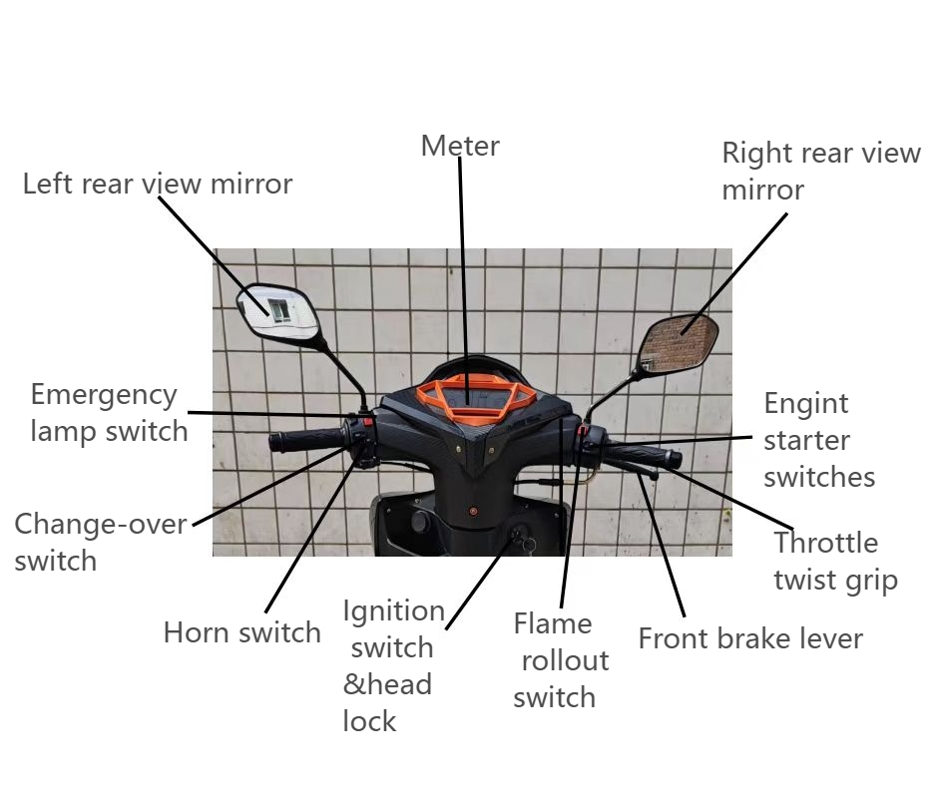
5

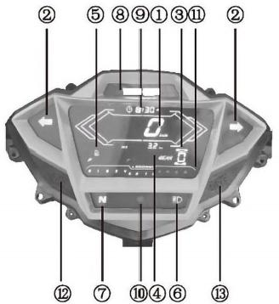

No. | Name | Description
① | Speedometer | Indicate the speed of the motorcycle (Km/h).
② | Turn indicator | The left light is on whenturning left,and the right light is on when turning right.
③ | Gear position display | Indicate the gear position of the motorcycle
④ | Odometer | Display the total mileage of the vehicle (Km)
⑤ | Fuel leve indicator | Indicate the fuel level in the fuel tank
⑥ | High beam indicator | It is lit up when the full beam is on
⑦ | Neutral indicator | When in the neutral position,the letter of indicator light N lights up
⑧ | Logo | When the instrument pane is turned on,the indicator lights up
⑨ | Clock | When the meter is turned on,the clock will work
⑩ | Photosensitive window
⑪ | Tachometer | It shows the speed(rpm)of the engine.
⑫ | The left button | The short technique to achieve ODO and TRIP,thestate of  conversation:in ODO state,long press to achieve measurement and imperialchange,and in TRIP state,long press to achieve zero trave
⑬ | The right button | Keep pressing until enteringthe clock setting mode,the clock flashes;In the clock setting mode,press briefly to achieve the current flashing bit+1;Press and hold to switch to the next  flashing.When the minute flashes,press and save ,then quit the adjustment mode.

6

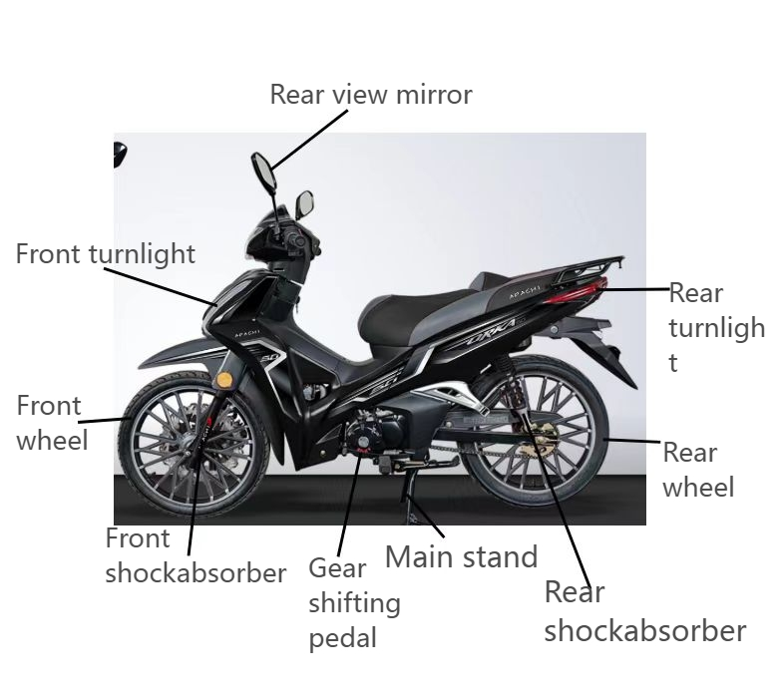

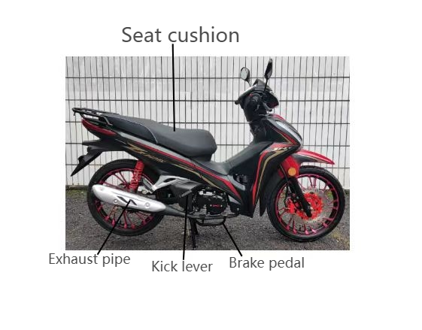8

IV.OPERATION

Ignition Switch
★Ignition swicth

Position | Function | Remarks
OFF | To stop thevehicle (swiching olf al circuits) | The key can be  removed outtaker
ON | hirsuaring or driving the vehiclelmaikingall themaincicuits) | The key cam no beremoved
LOCK | To lockthe steering handle | The key can be taken out
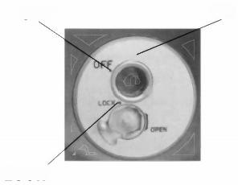
OFF
O
mm
IGNITION
sut

LOCK
ON

Fuel Cock
① Fuel filling
The capacity of the fueltank is 4.0L in total including 0.9L
of reserve.Leadless gasoline ofNo. 93 or above or low_lead gasoline is gequired for the motorcycle.To fuel the vehicle,support it by the main stand,open the lock cover of the fuel tank and fill fuel through theopening,and thenclose the tank by the cover with the two on them in good alignment.
② Operation of the fuel cock(the valve of fuel tank)
ON:With the handle of the fuel cock to“ON”position,the fuel circuit is through for fuel supply.
OFF:With the handle of the fuel cock to“OFF”position,the fuel circuit is cut off without

supply.
RES:With the handle of the fuel cock to RES position,the fuel is supplied from the reserve.
(Note:The reserved fuel can only be used when the normalsup- ply is run out.)In this case,refuel- ing should be carried out as soon as possible,for there is only some 0.9L of fuel reserve for use.

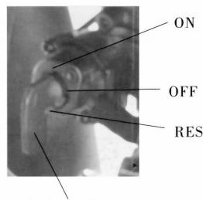
Fuel cockhandle
9

Engine Starting
①Set the key of theignition switch to“ON”position.
②Set the emergency stopswitch to“O”position.
③Ascertain the neutral position,where it should be displayed.
④Ascertain the amount offuel in the tank.
⑤Set the fuel cock handle to“ON”position. ★ To start a cold engine:
①Pull up the choke bar of the carburetor(to colse the choke).
②Rotate the throttle twist grip by 1/8 to1/4 turn.
③Start the engine by the electric or the kick starting system.
④Slightly turn the throttle twist grip to increase the speed of the engine so as to warm up the engine.
⑤Turn the carburetorchoke bar downward to"B",fully open the choke when the engine is sufficiently warmed up.

★Caution:
The engine can only be started after the neutral position is ascertained.Otherwise accident will happen.
Unnecessary idle running(especialy at a high speed)is harmful to the engine.
★Procedures of stopping engine:
①Release the throttle twist grip to slow down theengine.
②Turn to the neutral position.
③Set the ignition switch key to“OFF” position.
④Set the fuel cock(the fuel tank valve)handle to“OFF”position.

Switches on Right Handlebar
①Headlight switch
The Headlight switch has three positions"&" 、"P<" and"·"(a white point).
" ":When the switch is in this position,tail the headlight and meter lights are all lit up.
"P≤":When the switch is in this position,the tail, betraying and meter lights are lit up.
" ·":When it is in this position,the headlight tail, betraying and meter lights are all off.
The headlight and taillight will be lit up only after the vehicle is started.
②Electric start button(no such device for the vehicle of kick start mode only)
The electric start button is located below the
headlight switch.The engine will be started by Press- ing down this button.

③Emergency stop switch
When starting the engine,set the emergencystop switch in"冈 "position todirectly stop the engine by cuttingoffthe electric power.

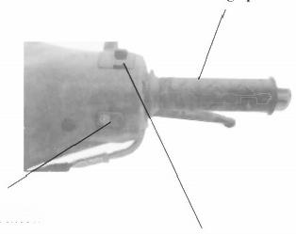
Thorttle twist grip

Start button
Front illuminator switch

Switches on Left Handlebar

①Light changing switch
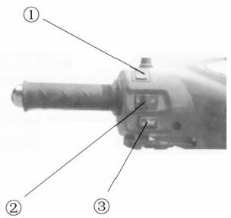
D position,Headlight is in high beam.
D position,Headlight is in low beam.
②Turnlight switch
Position,Left
Position,Right
③Horn button
Press this button to horn.

Gear Shift

Warm up the engine for normal runing.
①When the engine is idling,disengage the clutch and tread the gear_shifting pedal to et the gear to thelst position.
② Gradually increase the speed of the engine and slowly release the clutch lever,with a good coor- dination betweenthe two operations to ensure a natural driving start.
③ When the motorcycle reaches a balanced state of running,slowdown the engine,disengage the clutch again and tread the shifting pedal to change the gear to the 2ndposition.Thegearcanbeshifted to other positions in the same way.

Shifting forward
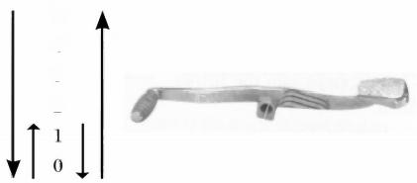
N
4
3
2
Shifting backward4

13

Machine Oil Checking
The vehicle should be
checked for machine oil before drive by supporting it with the main stand on a flat ground.The oil level should be between the upper and lower lines of theoil gauge,which is not screwed into the filling

V.Check-ups,Adjustments and Maintenance

Machine oil
 |  |  |  | 20 |  | M.6  0 | 0  26
 |  |  |  | 0 | 0  A3
℃ | -30 -20 -10.010203040
F | -22 -414325068.86104

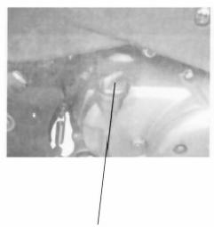
orifice.
High quality 4-stroke ma-
chine oil,as Class SEorSDin API classification,of SAE 15W-40QE in viscosity will help maintain a long service life of the engine.In case those are not available,a sub- stitute suitable for the ambient
temperature of application should be selected according to the table on the right side.
Machine oil gauge

Renewal ofMachine oil
Machine oil plays a very important role in the normal operation of the engine and for that reason,it is necessary to check the mo- torcycle for machine oil periodically and re- new the oil once every 800-1000 km of drive by the following procedures.
Remove the screw plug from the bottom of the hot engine to drain offall old oil.
Wash the oil filter screen clean and re- mount it really to position.Then fill in 0.9L fresh machine oil and start the enging for idle running 2-3 minutes..
Let the engine stop for 2-3 minutes,and check to see whither the oil livel is in be- tween the upperand lower line the oil gauge.
Do not use any machine oil of a different grade than the specified oneto avoid machinery failure.

Cleaning of Machine Oil Tank
①Drain off all the run-in machine oil from the oil tank.
②Dismount the related parts.
③Wash clean all the related parts.
④Fill in the required oil.
*This jobshould not be done by any untrained persons but shall be done at an authorized service center
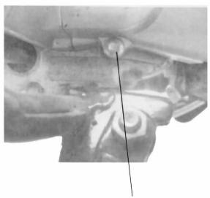
Screw plug for oil draining

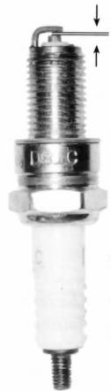
0.6～0.7mm

Check-up of Spark Plug
①Remove the cap of spark plug and screw off the spark plug by the plug wrench.
②Clean the spark plug all around or replace it ifit is corroded or there is too much deposit on it.
③Regulate the gap of the spark plug to 0.6-0.7mm.
④The spark plug of the desig- nated type should be used.
15

Check-up,Cleaning of Air Filter
Take out the air filter and check ifit is contaminated. Dismounting:
Remove the left side cover screw of the filter,open the left cover and disassemble theair filter
Cleaning:
Wash the filterin clean washingoil and wipe itdry with dry cloth.
Soak the filterelement in clean machine oil,squeeze it dry and fit it back to position.
Recommended oil:15W/40QE
Caution:
The air filter element for use must be intact or the engine will suck in dust and dirt,resultinging a shorter service life of the engine.
Wather should beprevented from entering into the filter in washing the vehicle.
The filte shall nerver loe cleamed with gasolinge on any other agentof a lowignition point.

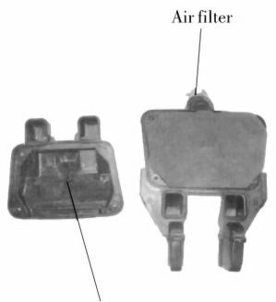
Collar clamp

Adjustment of Throttle Cable
Make sure that theadjusting nut of the throttlecable works normally.
Check to see if the throttle twist grip is with the required free operating movement.
The required free operating movement:2-6mm.
Ifthe grip can not be so moved freely,turn the ad- justing nut to ensure it.
*After adjustment,start the engine and check for the free operating movement again. Repeat the adjust ment if necessary until it is as required.

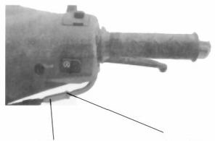
Adjusting nut Locking nut

Adjustment of Carburetor
Caution:
The idling speed adjustment of the engine should be carried out with a hot engine.
Set the idling speed to the required value by the helpof the idling speed adjusting screw with the vehicle standing on a flat ground.
The required idlingspeed:1,500 r/min.

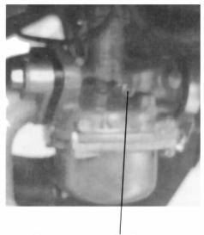
Idling speed adjusting screw
17

Check-up &Adjustment of Air Valve Gap
Noise will stem from too big gap of the air valve.However if there is too small gap or even no gap at all,closing of the valve will be hindered,which will cause burn of the valveand output drop.Therefore,the airvalve gap must be checked periodically.
The gap of the air valveshould be inspected and adjusted with a cold engine by the following procedures:
①Remove the caps of the central holeand the top hole(the ignition timing observation hole)in the left crank- case cover.
②Remove the caps of the two air valves on the cylinder head.
③Insert the "T"key into the central hole of the crankcase cover,jam itagainst ghe nut of the flying wheel and then turn the flying wheel clockwise until the engraved "T"mark on the flying wheel aligns with the engraved line on the top of the crankcase cover.Swing the rocking arm slightly.A loose rocking arm(which indicates the existence of clearance)shows that the piston is in the lowerstop position of the compressing stroke.In this case,continuously turn the"T"key colckwise for 360degrees until the alignment of those engraved marks,where the valve can be adjusted. Afterwards,check the valve gap by inserting a feeler in between the valve adjustingscrew and the end ofthe valve.
The specified air valve gap:0.03-0.07mm for the intake and exhaust valves respectively.

8

④ If the adjustment needed,loosen the locking nutof the valve,turn the adjusting nut till a slight resistance is felt on inserting the feeler
At theend of the adjustment,tighten the"Locking nut"to prevent loosening and conduct another check to make sure that the valve gap is OK before all those dismounted caps are refitted on.

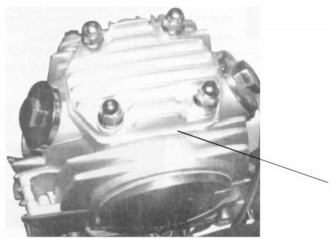

Central hole cap

Adjustment of Clutch
★The clutch should be adjusted with the engine in stopped state.
There should be a free operating move- ment of 10-20mm at the endof the clutch le- ver as shown in the figure on the right side.
When adjustment is needed,loosen the locking nut on the clutch operating cable and set the clutch lever to the required range of free operating movement.In case of adjust- ment to be made to a great extent,turn the clutch adjusting screw studon the right crankcase.
Is tart she engine to ascertain whether the adjusted clutch works normally.
★Readjustmenthas to be made ifthere is slipping of clutch or difficulty in the en- gagement ofgears.

Rrake Checking
(1)Pull up the front and rear brakes respectively and check for wear of the brakeshoes.If the mark""on the brakedrum cover aligns with that""on the brake cam,it means that the brake
shoes are already worn to the limit and have to be.
(2)Replacement should becarried out at a designated ser- vice center and it is recommended that the parts made by our company are used therein 10-20mm.

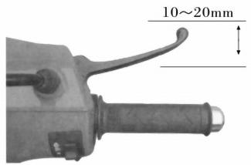

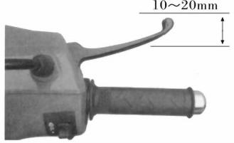
Adjustment of Front Brake
(1)The front brake lever has a free operating movement of 10-20mm as shown in the figure on the right side.
(2)If adjustment is needed,turn the adjusting nut near the lower side of the front hub,clockwise to re- duce and counterclockwise to increase the freeoper- ating movement of the brake lever
(3)After adjustment,the groove of the adjusting nut should be aligred with the pin of the brake arm.
Caution:
After adjustment ,check the front braking system.The braking light should be lit up on time when the front brake is applied by gripping the brake lever.

Adjustment of Rear Brake
★The vehicle shoule be sup- ported by the main stand for check.
(1)The rear brake pedal has a free operating movement of 20-30mm as shown in the figure on theright side.
(2)To make adjustment ,turn the rear brake adjusting nut clockwise to reduce and counterclock wise to in- crease the free operating movement of

Adjustment of Chain
Rear brake pedal
★Check the chain for wear,tension and lubrication.
(1)With the motorcycle supported by the main stand,turn the upper and lower portions of thechain by hand to check for its tension to see if the sag is within the specified range of 10-20mm.
(2)When regulation is needed,loosen the axle nut and locking nut of the rear

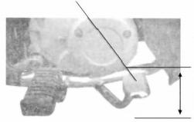
wheel,then set the chain to the required
20～30mm
the brake pedal.
(3)After adjustment,the groove of the adjusting nut should be aligred with the pin ofthe brake arm.
Brake cam Brake pull rod tension by turning the adjusting nut.
(3)Apply a little grease to the chain.
Caution:
At the nd of regulation,the
Caution:
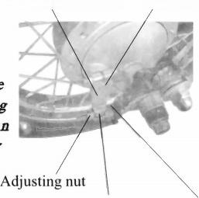
After regulation,check the marks on the chain adjuster should
rear braking system.The braking be in good coordination with the
lightshould be litu on time when engraved line on thehorizontal fork
the rear brake is applied by al position is concerned.
stepping down the brake pedal.
22 Rear brake arm Brake arm pin

Chain adjuster(with graduations)
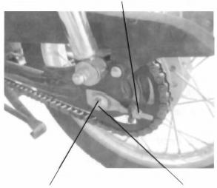
Rear wheel axle nut Bear axle

Braking light switch Adjusting nut
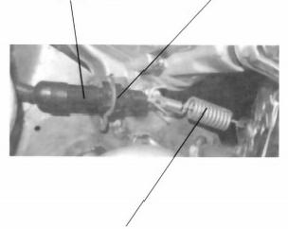
Braking light switch spring

Adjustment of Braking Light Switch
★The braking light ahould be lit up on time as soon as the rearwheel is braked.If not,regulationshall be made by turning the adjusting nut.
★With the braking light switch in "ON"position,the braking light should be lit up.If not ,check should be carried out to see shether the braking lamp,circuit and switch work normally,Make replacement if needed.
Caution:
For the adjustment of the braking light switch,the brake needs to be first checked to make sure that the free operating movement is ensured within the specified range.

Battery Vhecking
①Open the right side cover.
②Clean away dust and corro- sive from the surfaceofthe battery.
③Set the vehicle in a vertical po-

willoccur
sulfiacidetrlecausos
hurt to skin and eyes bycontact.In
case ofcontact with it,wash it off
for5 minutes and see a doctor im-

Replacement of Fuse
Set the ignition seitch to "OFF"position.The specified fuse tube of 15A shouldbe used for replacement.

mediately.
sition to see whethe the level ofthe bat- tery electrolyte is between the upperand lower mard lines.Ifit is below the lower one,distilled water shall be added to the
Foreign matter should be prevented from entering into the batteryduring dismounting and
installation.
battery.
④Seriously corroded conductor connectorsof the battery shall be replaced
Caution:
To dismantle battery,
disconnent the negative(-)
The breathingpipemustbekept
unblocked.
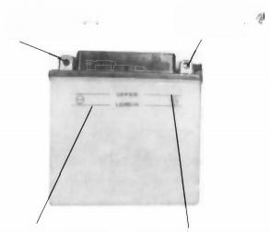
Negative(-) Positive(+)
connctor connctor

level come over the upper mark line when adding distilled water.
electrode before thepositive(+)one,
andvice versa in installation.
Ensure against any contact of the
positive(+)electrode with the
vehicle body.
Never have the electrolyte
Otherwise overflow and corrosion Lower electro- Upper electrolyte
lyte level line
24
level line

Open the left side cover,
remove the fuse holder on the siede of the battery and replace the fuse tube.
If the new fuse tube is broken again as soon as it is fitted on,it means that there is some trouble with other elec- tric parts.
Caution:
Do not use any fuseover 15A
Be sure notto wash the battery when washing the vehicle.

Vehicl Washing
Cleaning the vehicl regularly can slow down the color fading of its body make it easier to check if there isany damage and any oil leakage with it.
Caution:
Washing the motorcycle with over-pressurized water may cause damage to some of its components.Therefore,do not jet over-pressurized water directly on to-the following parts:
——Wheel hub
——Exhaust pipe
——Fuel tank and lower portion of cushion ——Carburetor
——Head lock and ignition switch ——Meters
(1)After pre-wiping,the vehicle shoule be washed with clean water to remove dirty residues so as to prevent
corrosion.Plastic subassemblies should be cleaned by wiping with colth orsponge soaked in neutral detergentsolution, followed by washing with clean water.
(2)Afterthe cleaned vehicle is air dried,grease the chain and run the engine at idling speed for a few minutes.
(3)Prior to driving,carefully check braking system repeatedly and repair of adjust it if necessary.

Maintenance in Non-use Time
Storage and Maintenance
For the motorcycle to be stored for a long period of time,attention should be paidto the prevention of moisture, sunshine and rain attack in order to protect it from un- necessary damage.Special check-ups should be carried out on those important parts and subassemblies befor storage.
①Change lubricating oil.
②Grease the chain.
③Drain off fuel from the fuel tank and carburtor (forthe vehicle not to be used for over a month,the fuel in the latter must be thoroughly drained away),turn off the fuel cock and fill antirust solution into the fuel tank, followed by closing the tank wyth the cover:
Caution:
As fuelis inflammable ,the engine should be stopped before filling ordrain fuel and it is prohibited to smoke at the fuel storing,filling ordraining location.

④Take out the spark plug,fill about 15-20ml of clean lubricating oil into the cylinder,step down the kick lever repetitively for several times and finally fit the spark plug back on.
Attention:
The ignition switchkeymustbe set to
"OFF"position before stepping down the
kick lever.To protect the ignition system
from damage,the spark plug should be put
on its cap and earthed.
⑤ Dismantle the battery and put it in a shady, cool and well-ventilated place.It is suggested that the battery be charged once a month.
⑥Clean the vehicle,spray the colored part with colorfastening agent and apply antirust oil to thepart vulnerable to rust.
⑦Inflate the type as required and pad the ve- hicle up with the two wheels clear of the ground.
⑧Put the coveringover the motorcycle.

Resumption of Service
①Remove the cover and clean the vehicle.Change the lubricating oil if the vehicl has been off service for over 4months.
②Charge the battery and remount it.
③Drain off the antirust solution from the fuel tank,followed by filling fuel therein to the required level.
④Prior todriving,test the vehicle at low speed in a safe place. Maintenance Routine Diagram
The vehicle should be under good maintenance as specified in the following table,where; "I"means:Check,cleaning,adjustment,lubrication and/or replacement are needed.
"C"means:Cleaning is needed.
"R"means:Replacement is needed. "A"means:Adjustment is needed. "L"means:Lubrication is needed.
"*"means:This item of maintennace should be carried out at a service center.It may be also done by the user himself with reference to this manual provided he has special tools,sparts and is capable of this job.
"**"means:This item can only be carried out by the serviceman at General Accessories Corp.service center in orderto ensrue safety.
Notes:1.Maintenance should be conducted more frequently when the motorcycle drives in dusty areas.
2. When the read-outofthe odometer exceeds the maximum figures specifiedin the table,maintenance shouldbe still cycled according to the intervalofmileage statedherein.

Frequency Item of Maintenance |  | item/Frequency | Odometer km(Note 2)
 |  | item/Frequency | 1000km | 4000km | 8000km | 12000km | Remark
★ | Circuit of fuel system |  |  |  | I | I
★ | Fuel filter |  | C | C | C | C
★ | Throttle operating sysem |  | I |  | I | I
* | Choke of carburetor |  |  | 1 | I | I
 | Airfilter element | R-yearly |  | C | C | C
 | Spark plug | R-yearly | I | I | I | R
* | Air valve gap |  | I | I | I | I
 | Air valve gap |  | I |  | I
 | Engine lubricating oil |  | R | One replacement every 2000km
 | Lubricating oil screen | Monthly |  | C | C | C
★ | Tension of chain |  | A | A | A | A
★ | ldling speed of carburetor |  |  | I | I | I
 | Driving chain | B-4 vea |  | I、Levery 500km
 | Battery |  | I | I | I | I
 | Wear of brake shoes | r-2year |  | 1 | I | I
 | Rearbraking system |  | I | I | I | I | alsofor dise style
** | Braking liquid hose |  |  | 1 | I | I | alsofor dise style
*大 | Cup of braking liquid | I | I | I | I | I | alsofor dise style
** | Braking liquid |  | One replacement every two year
★大 | Front braking system |  | I |  | I | I
★ | Rear braking light switch |  | I | I | I | I
★ | Light changing of headlight |  | I | I | I | I
 | Clutch |  | I | I | I
 | Side stand |  |  | I | I | I
* | Suspension |  | I | 1 | I
★ | Nuts,bolts &other fasteners |  | I | I | I | I
** | Wheel/spokes |  |  | I | I
★★ | Bearing of steering handle |  | I
28

Remote-Controller's Function Operation And Instructions
Function operation:
●Set acousto-optic anti-theft:

●Remote-control starting:
Press the button to igniteand drive the motorycycle without start.if difficult,press the button longer til starting.
Press the button to stop the motorcycle in the state

Press the button The hown will sound &the turmlight of remote-control starting.

flash once.three seconds later,be in thewarning state of acousto-optic antitheft.
●Anti-theft sensing:
In the state of anti-theft,any shock to the motor- cycle makes the system present impedance followed with horm sounding once &turnlight flashing once,incase of further harassing activities within the following three

● Anti-rob:
In the state that the engine is working,press the button to stop the motorcycle in such emergencies as being robbed of or stolen.
●Acousto-optically target-seeking:
Set acousto-optic anti-theft,therr seconds later, press the button for hom and light flash so as to find the

seconds,the system is to sound the alam immediately;motorcycleat the parking lot.
horn ringing,turnlingtflashing and engine being lockde Instructions to remote-controller use.
automatically.remain warning state after the alarm ●The function of remote-control startingonly ap-
stopped automatically.in case the motorcycle is stolen,plies to the motorcycles which is equipped with auto- electricswitch shall flashing and enginebeing lockde matic transmission orable to electrically start

autor\matically.
●Anti-theft relieving:
In the state of anti-theft,press the button and the hom will sound twice &the lightflash twice to relieve the state of anti-theft.

● Pay attention to the prevention of soaking,hard throwing and high temperature to aviod natural loss of electrical power.
●Do not put the keys to the remote-controller into the lock. 29

ELE CTRICAL DIAGRAM
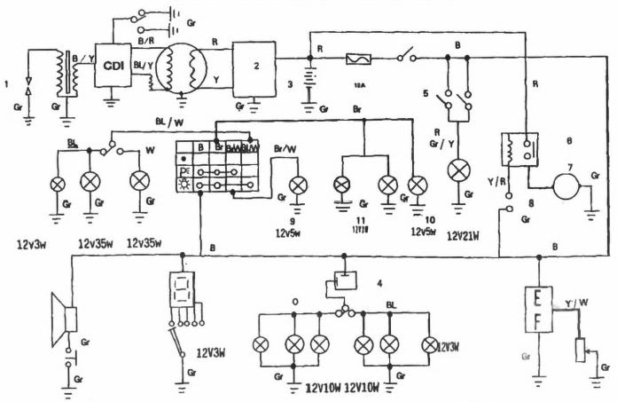

 | (1)Spark plug  (2)Regulator  (3)Battery  (4)Fuse  (5)Braking switch | (7)Start motor  (8)Start button  (9)Brake light  (10)Taillight  (i1)Meter light | B-Black Y-Yellow W-White BL.BLue
30 | (6)Start relay | Gr-Grey | 0-Orange Br-Brown



